

Revit Guidelines - Element Tools

Mario Guttman - Firmwide CAD Director

Rev 2009-06-23

I. Overview 2

A. Settings INI File. 2

II. Creating Areas and Rooms 3

A. Process Overview 3

B. Placing Unplaced Areas 4

C. Placing Unplaced Rooms 5

D. Creating Rooms from Areas 7

III. Making Room Data Sheet Views and Sheets 8

A. Process Overview 8

B. Creating Views from Rooms 9

C. Creating Tagged Views from Un-tagged Views 10

D. Exporting Images from Views 11

E. Creating Sheets from Views 11

IV. Existing Element Utilities 12

A. Managing DWG Attachments 12

# Overview

The Element Tools are a collection of utility functions that are available from the HOK menu in Revit. They are group together for convenience and because they are somewhat similar in the way that they act on elements.

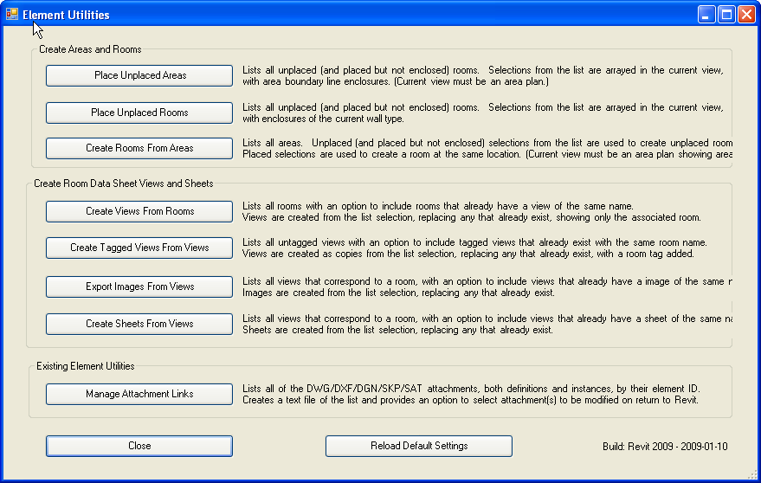

Main Menu

The **Element Tools** command, on the HOK Menu, opens the **Main Menu** which is used to access the individual commands. Each command is described separately in the following sections.

## Settings INI File.

If the Revit project has been saved, all of the user settings are saved to a file called **ElementTools.ini** in the same folder where the Revit project file is located.

The Reload Default Settings command restores all of the settings to predefined defaults (which are not user definable) and saves a new .ini file, if possible.

The defaults are set to support a particular workflow and can help to understand the intention for how the commands are intended to be used.

# Creating Areas and Rooms

## Process Overview

There are a number of possible workflows in which area and room data is developed in advance of the architectural design. In many cases these also involve the use of the **RevitDbLink** tool for synchronizing an Access database with the Revit model. (This tool is not discussed here but the Creating Areas and Rooms commands were developed to work with it.)

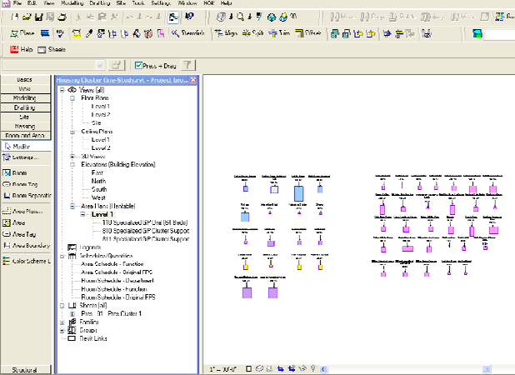 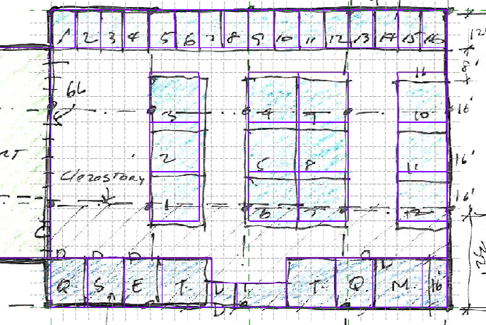

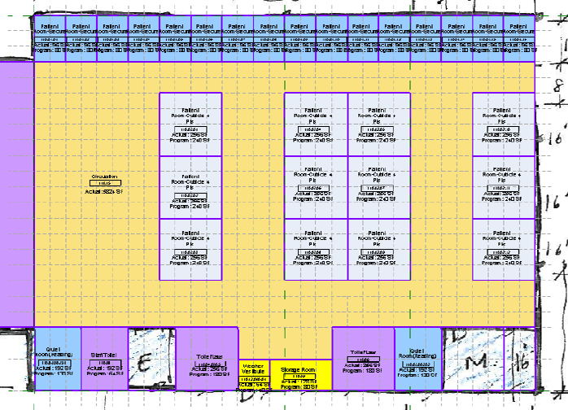 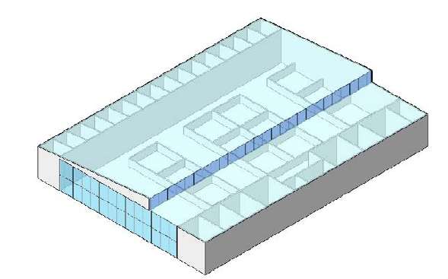

Examples of Using Spaces to Develop a Schematic Design

A typical workflow includes (in no particular order):

* Developing data about the spaces needed in the database and transferring this data to the Revit model as unplaced areas, with parameter data values   
  pre-assigned. (RevitDbLink)
* Using the **Element Tools** to place the areas in the model, sized to their required area, bounded by area boundary lines.
* Using the areas to develop massing and work with analysis tools (such as EcoTech.)
* Using the area boundaries as reference lines to create walls.
* Developing data about the rooms needed in the database and transferring this data to the Revit model as unplaced rooms, with parameter data values   
  pre-assigned. (RevitDbLink)
* Using the **Element Tools** to place the rooms in the model, sized to their required area, bounded by walls.
* Using the **Element Tools** to convert areas to rooms that are placed at the same location as the area and carry the same parameter data.

## Placing Unplaced Areas

The purpose this command is to take unplaced areas and place them in an area plan, bounded by area boundary lines, and sized according to their required area.

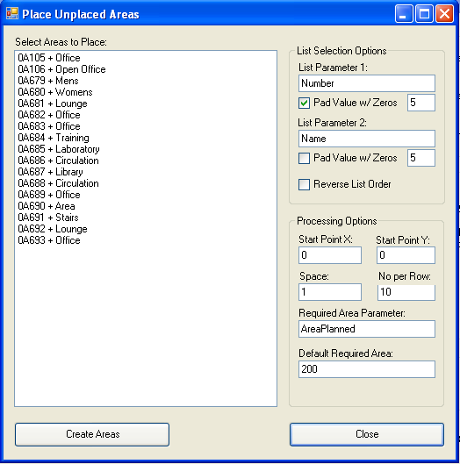The list shows all of the unplaced areas. (It also includes areas that are placed but not bounded; this is not really intentional.)

The "Parameter Name 1", "Pad Zeros", "Reverse List Order" etc. control how the list is displayed.

The start point, space, and number per row should be set to control where the array of new areas will appear.

The "Parameter with Required Area" can be any area parameter with the area that is the program requirement for the room. It will determine the size of a square-shaped area that is placed.

One or more items from the list need to be selected before pressing the "Create Areas" button (use Shift and Ctrl buttons to make multiple selections.) The areas will be created in an array with their proper sizes. This command must be run from an Area Plan.

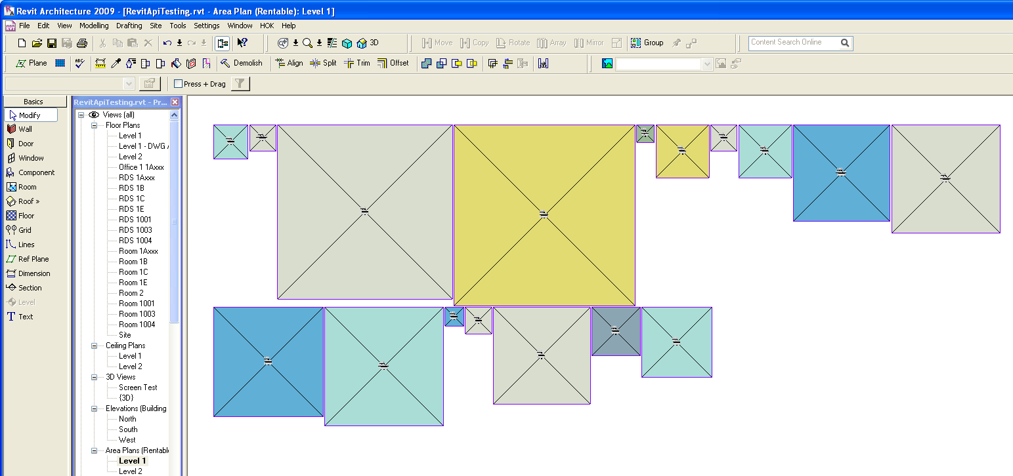

## Placing Unplaced Rooms

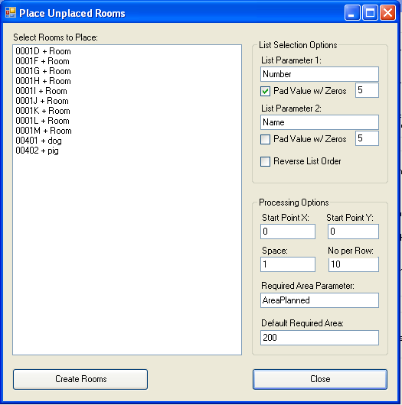This command is similar to the Place Unplaced Areas command but works with unplaced rooms and places them in a floor plan, bounded by walls, and sized according to their required area.

The list shows all of the unplaced rooms. (It also includes rooms that are placed but not bounded; this is not really intentional.)

The "Parameter Name 1", "Pad Zeros", "Reverse List Order" etc. control how the list is displayed.

The start point, space, and number per row should be set to control where the array of new rooms will appear.

The "Parameter with Required Area" can be any room parameter with the area that is the program requirement for the room. It will determine the size of a square-shaped room that is the appropriate area.

One or more items from the list need to be selected before pressing the "Create Rooms" button (use Shift and Ctrl buttons to make multiple selections.) The rooms will be created in an array with their proper sizes. This command must be run from a view that allows the creation of rooms (it cannot be a schedule, for example.)

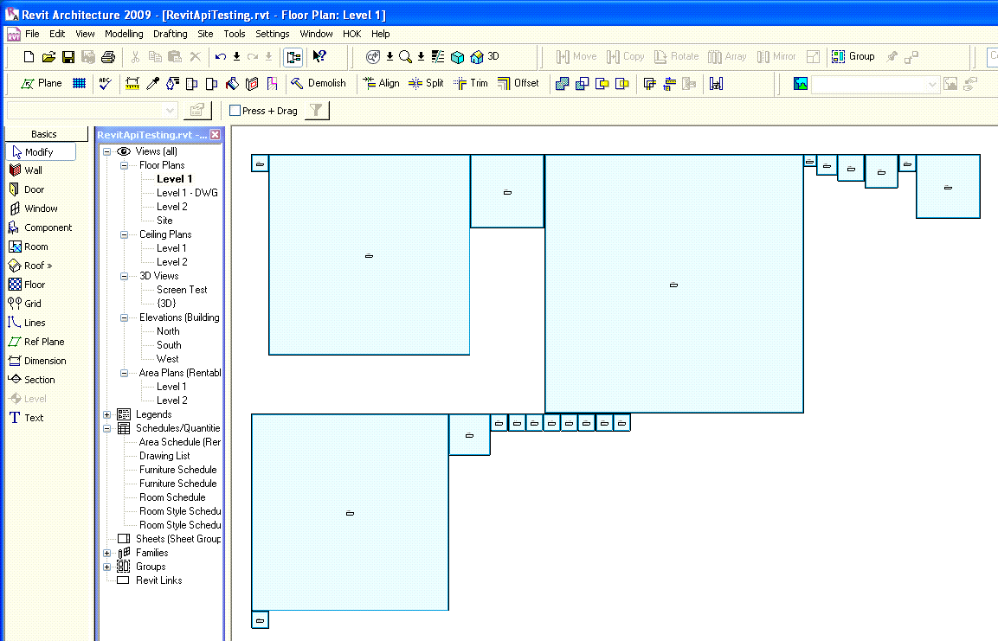

## Creating Rooms from Areas

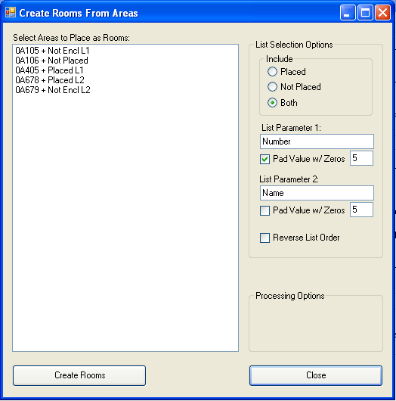This command has a similar interface. It lists the unplaced areas (including those that are placed but not bounded) and/or placed areas depending on the selections settings. When some areas are selected and the "Create Rooms" command started, a new room is created for each area.

Unplaced areas result in unplaced rooms.

Placed areas cause a room to be placed at the geometric center of the area. Depending on the walls it will either be unbounded or fill out to the walls. Note that this command must be run from a view that shows the placed areas.

Note that the program does not check for duplicate room numbers. It will create a room that already exists properly but then show a Revit warning.

# Making Room Data Sheet Views and Sheets

This group of commands is designed to support a workflow for creating room data sheets from Revit in connection with the use of the **RevitDbLink** program to synchronize the data.

Room-views and associated data may represent generic rooms or actual rooms at different stages of the project.

## Process Overview

It is assumed that a variety of data sources will contribute to a **Database System** that is composed of the Revit model and an Access database that are kept synchronize where they hold duplicate room data.

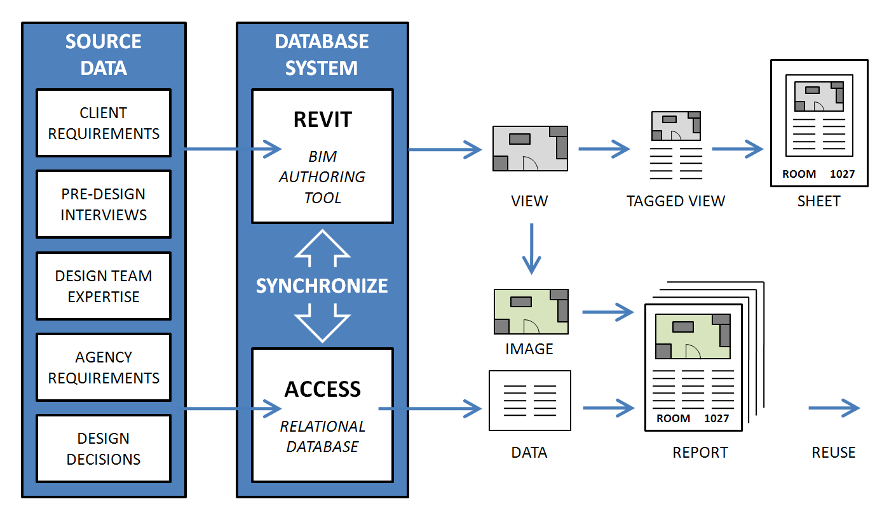

Two different ways of creating reports are anticipated. Either one of these may be used exclusively, or they may be used simultaneously.

### Revit Sheets

For each room, a special view is created, with its crop-box set to only show that room. The room is tagged with a special room tag that displays the room data stored in the room parameters.

For each room a separate sheet is created, generally in a smaller format (such as 8-1/2” x 11”).

These sheets can be used to print a report but their real advantage is that they are very useful in interacting with the client to refine the room requirements since they are always exactly up-to-date.

### Access Report

An Access report includes an image that is populated by a linked file (such as a .jpg file) where the path to the image is generated automatically by a function of the room name.

For each room, a special view is created, with its crop-box set to only show that room, as in the previous process, except that the room is not tagged with the special room tag that displays the room data stored in the room parameters Instead, the room data is displayed as a conventional Access report.

This process is more suited to delivering a final report and has more potential for continued use of the database during design development and documentation, and on to facility management.

## Creating Views from Rooms

Both workflows begin with creating the initial view. (The automatically cropping function is not currently working so a rectangle is displayed to assist in manually setting the crop box.

The list selection option are similar to the previous commands.

The **Room Parameter - View Name** is the parameter that will be used to create the name for the view (typically the room number.)

The **Room Parameter Room Name** is a parameter that will be copied to the **Name on Sheet** parameter for later use in making the sheet. (typically the room name.)

The **Space Around Room** defines how large the crop box is in addition to the room size.

The **View Name Room Prefix** is pre-pended to the view name in front of the parameter value.

## Creating Tagged Views from Un-tagged Views

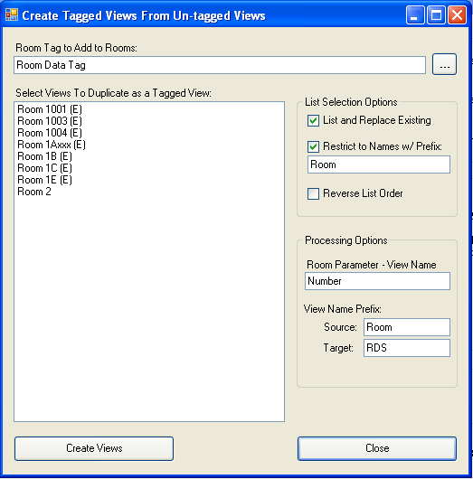For use with Revit-based room data sheets, a copy of the initial view is made and the special room tag is placed in the center of the room. (The crop box function is currently not working so a line is drawn instead for now.)

The Room Tag to Add to Room text box allows the entry or selection of a room tag, which must already exist in the project.

The **Room Parameter - View Name** is the parameter that will be used to create the name for the view (typically the room number.)

The **View Name Prefix: Source** value is the prefix that should have been used with the view that is being copied.

The **View Name Prefix: Target** value is the prefix that will be applied to the view that is being created.

## Exporting Images from Views

For use with Access reports, an initial image view is made and written to a file. (Currently we are writing .dwf files that will need to be converted to .jpg files due to limitation in the API. This isn’t really resolved.)

The **Folder in Which to Place Images** field must contain a full path to an existing folder. (The selection command allows the creation of a new folder.)

## Creating Sheets from Views

For use with Revit-based room data sheets, this command makes the sheet files that correspond to the views.

The view is added to the sheet. (We haven’t really resolved the location and scale of the placement; this is under development.)

The **Titleblock to Use for New Sheets** must refer to an existing titleblock in the project.

(Generally users will want to change the viewport to one without a title bar however we have not found a way to automate this.)

# Existing Element Utilities

At the moment there is only one command in this group.

## Managing Attachment Links

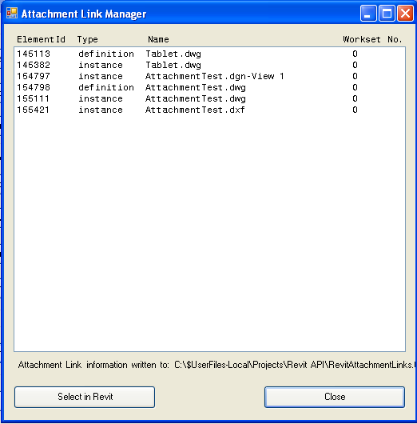This command simply looks for all dwg/dxf/dgn/skp/sat attachments. It is useful for debugging problems with worksets and other issues regarding the display of the attached files.

If the project has been saved, the results are written to a text file in the same location as the project file.

There is also an option to select one or more of the items in the list and then use the **Select in Revit** command to have them pre-selected in Revit when the Element Tools dialog boxes are closed. This can be used to find further data about the attachments,   
change their workset or   
other properties, or delete them.

(Unfortunately, it is not currently possible to display the workset name in the list.)